Friends and Family Comments August 2023
RESULTS: 110

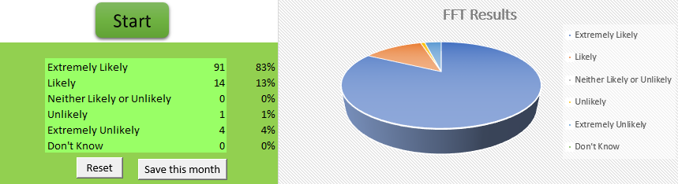
- Great team
- No waiting, friendly reception and quick procedure
- Can always get appointment whenever required. Very helpful reception staff
- Dr Jeyam has been fantastic and friendly and all the receptionist team has been fantastic as well
- Got seen on the same day
- On time & prompt
- Great professional nurse give some really good advice and was very polite cannot recommend more highly
- I gave the answer because I was asked for it. The experience was very good, by the way
- Dr and Nurse very nice, helpful and understanding and explained very thing to us
- Because I'm satisfied
- I felt better having discussed and addressed a few of my problems
- The new Dr whom I’ve never seen before was so thorough, sympathetic I genuinely felt she understood my situation, well done Dr Jeyam & Dr Jesudas Surgery
- Excellent service
- Invariably treated courteously and with understanding
- Your all very good you’re the best
- I went in on time and Dr Watson was very good
- Very pleasant person informative and knowledgeable easy to talk to
- I was very pleased with the appointment found the nurse very helpful and polite
- Very very patient with me, even when I wussed out and felt faint
- Wasn't notified of a time for the online consultation
- Phoned for app at 10am and was seen face to face by a Dr at 11.10 am
- Good availability of appointments, helpful staff
- Excellent service
- Prompt and efficient service from all
- The service was very good
- As always a professional approach to health issues
- I don’t have to wait long for appointments need improvement on a few things
- It was easy
- James Limbert is a fantastic clinician he was very welcoming. He explained everything very clearly and I didn’t leave feeling like I was rushed. He explained the various roots I could take for a treatment plan for my elbow pain. He is a very good asset to the surgery
- Went in on time and the nurse was very good
- Good doctor all ways treated nicely
- Very professional approach always get an appointment
- Very helpful
- appointment same day
- Lovely lady on reception Dr Kathuria was very helpful as always
- The appointment was with the Practice Nurse Janine, she was very thorough, knowledgeable and approachable
- I didn’t wait long to be seen my appointment was at 8.30am I got there 8.25am
- Had blood test only had to wait a couple of minutes great service
- The practitioner was very helpful and gave me enough time to talk about my illness
- Dr very pleasant and gave me a good check over
- Always happy with the service I receive
- Friendly helpful team from receptionists to GP to nurses
- Prompt satisfied
- they are just so helpful and polite
- Seen on time, practice nurse suggested I see GP and was given an appt 30 minutes later. Receptionist very polite &amp; helpful
- They spent time with me for me to explain why I feel the way I do etc for them to get me the right help etc
- all very pleasant from receptionist through to doctor
- Very professional and friendly
- I when in today and it was so so quick and earlier than expected. I thought I will still have to sit longer time but no, it was quick
- Excellent information received. Questions answered and future consultation confirmed
- Always time to listen. Clear explanation of treatment. Extremely pleasant and helpful receptionists
- Found Raz easy to talk to I felt at ease in her company, a very approachable person
- Very professional
- Easy
- All the staff are very friendly and try and do their patients, Reception staff are very friendly
- Brilliant as always from. Reception to GP Dr Watson
- Dr Kathuria is very kind and caring doctor with impeccable knowledge. What every GP should be like. Reception staff are always super nice, friendly and helpful as always. Never had a bad experience at this practice
- Because I am very reassured if there is ever a time I need to see my doctor regarding any problems I may have
- Got an appointment the same day I rang reception
- My GP surgery always goes the extra step
- Appointment booked with no problems and was on time
- Professional
- Quick and efficient
- Good explanation for my overall health
- Receptionist was nice and so was the nurse. Clean and sterile
- They are always helpful and very good
- Everything went well
- Very polite and friendly and understanding
- Very friendly and nice nurse
- Always pleased with the service I receive
- Very attentive and welcoming. Made me feel relaxed and lovely personality
- It's a very good doctors always helpful

